**CASCADING STYLE SHEETS**

**Syntax Style**

* Element **IDs** are prefixed with **#** (for example **#f0f0f0**).
* While classes are prefixed with (**.**) (for example **p.intro**).
* Whatever we write between **{}** are known as ***style declaration***.
* Style declarations within same curly braces are separated by (**;**).

Properties in CSS:-

* ***color***
* ***font-family***
* ***font-size***
* ***background-color***
* ***margin***
* ***opacity***
* ***padding*** (spacing within element’s border) etc.

More about CSS:-

* When **multiple rules** are applied on an element, then the rule with **highest preference** is applied.
* ***Style inheritance*** is possible in **CSS**.
* **CSS** allows us to style websites for **various screen sizes** & **devices** using ***media queries***.

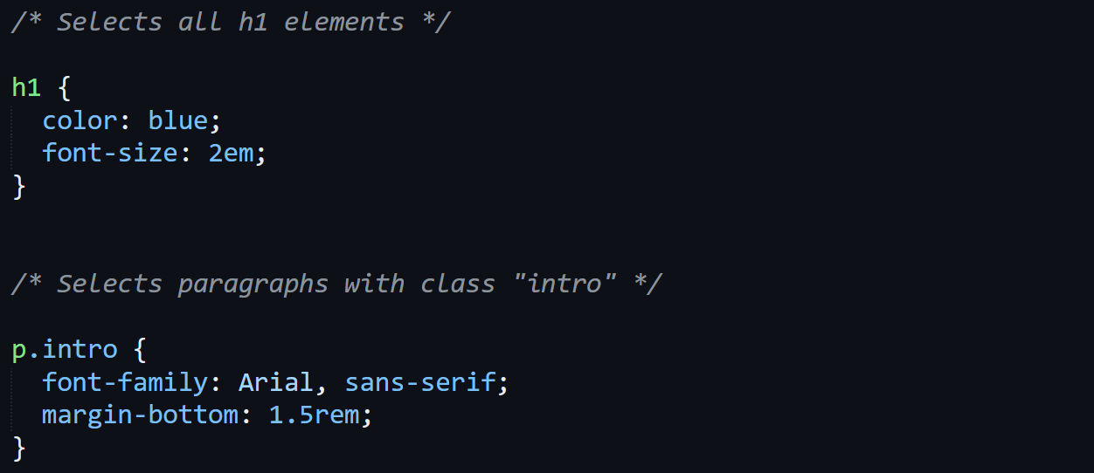

**Embedding CSS With HTML**

Inline styles:-



Internal stylesheets:-

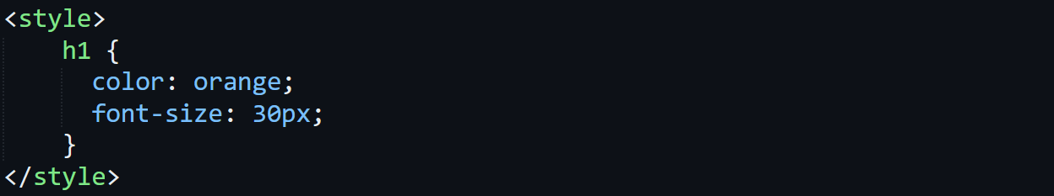

External stylesheets:-



**Box Model**

Parts of box model:-

* **Content:** Core part which can be **text**, **image**, **video** etc.
* **Padding:** Transparent area covering the content.
* **Border:** Border for **content** & **padding**.
* **Margin:** Transparent area outside the border.
* These 4 can be used as **properties** in **CSS** codes.

Display properties:-

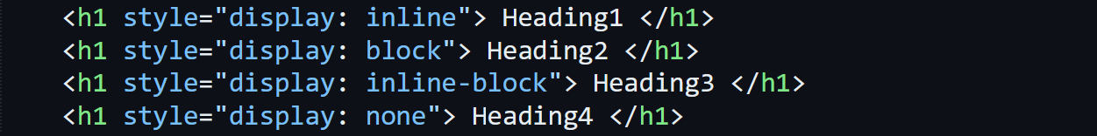

* Inline means regular lines.
* ***block*** texts are treated as being **inside block**.
* While ***none*** are **not** visible on webpage.

Positioning:-

* It refers to the ability to **control the position** of an element with respect to its **default position**.
* **Static:** The **default** position of the element.
* **Relative:** Element is **shifted** but **moves** when page is **being scrolled**.
* **Absolute:** Placed relative to their preceding ancestor & **doesn’t** flow.
* **Fixed:** Stays **fixed** when the page is being scrolled.
* **Sticky:** These elements flow to a certain point & then **stop flowing** while the page is being scrolled.

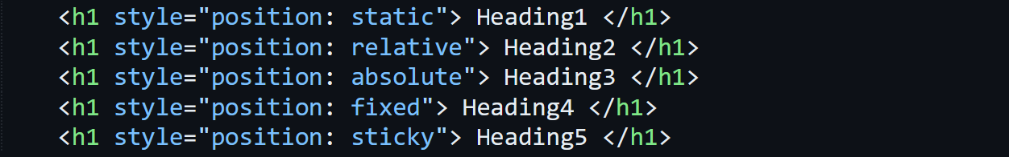

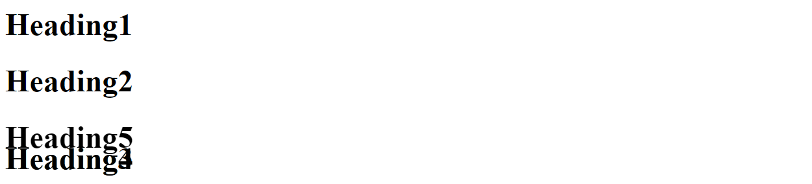

**Responsive Design**

Media queries:-

* **Breakpoints** must be defined in order to adapt the webpage for various devices.
* For **mobiles**, it is around **320px** to **480px**.
* For **tablets**, it is around **480px** to **768px**.
* For **laptops**, it is around **768px** to **1024px**.

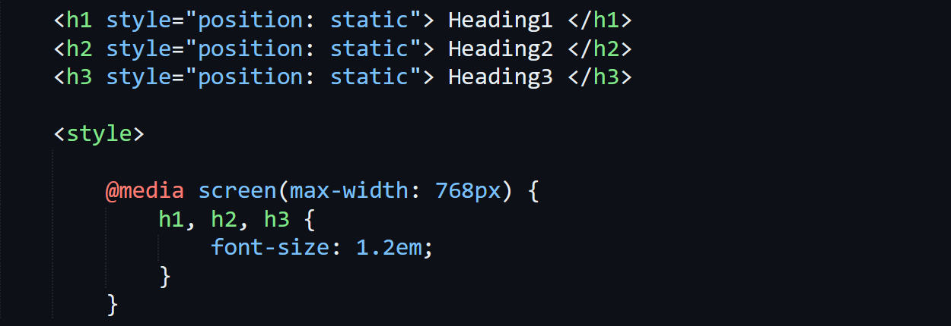

* ***@media*** defines **type of media** we are targeting, like here it is **screen**.
* Other than ***max-width***, we can also use ***min-width*** or ***orientation***.

Flexbox:-

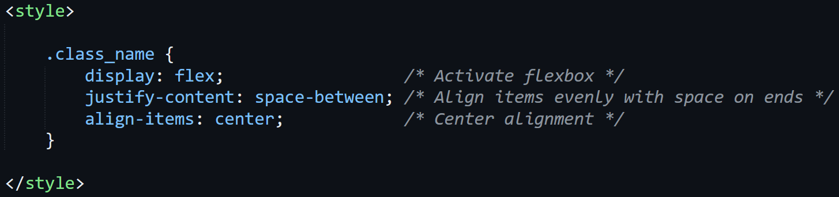

Grid layout:-

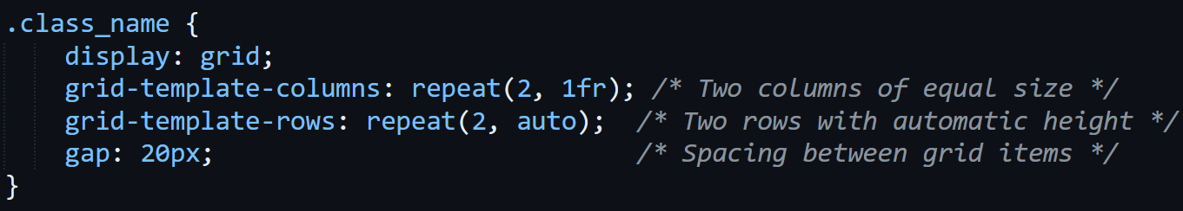

* ***1fr*** means ***1-fraction***, so ***(2, fr)*** means the column is divided into **two equal parts**.

**Animation & Transition**

Animation:-

* Uses @keyframes.

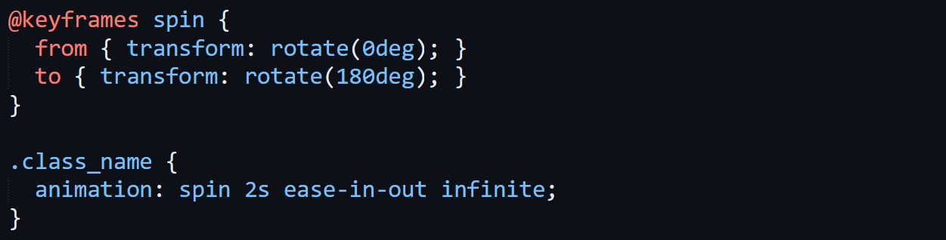

* Spins **"from"** to **"to"** in **2 seconds** for ***infinite*** number of times (as per syntax).
* The time parameter can also be in **milliseconds**.
* ***ease-in-out*** gives a **soft** starting & ending to the animation.
* To get a **constant motion** in animation, use ***linear*** instead.
* Writing a number **'n'** instead **infinite** results in **'n'** number of rotations.
* More animation can be added to same element, separated by commas.

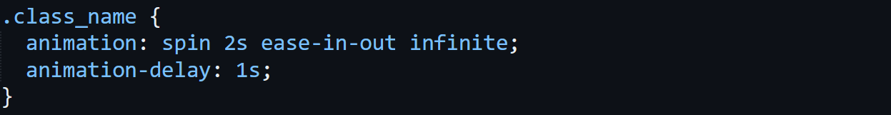

* ***animation-delay*** delays animation for **1s**, then the animation starts.

Transition:-

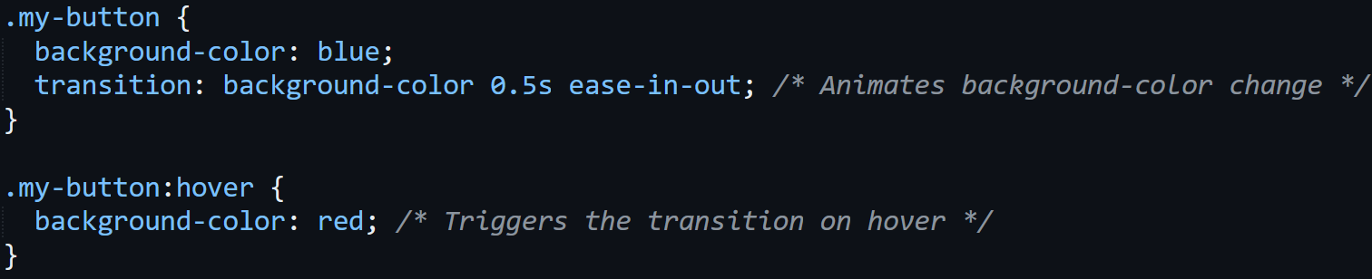

* Changes ***background-color*** from ***blue*** to ***red*** when hovered.

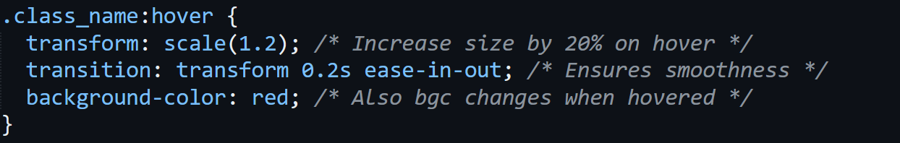

* In this one, **not** only the colour changes but also the **text is zoomed** smoothly.